CUNNINGHAM CLASSIC 2017 | 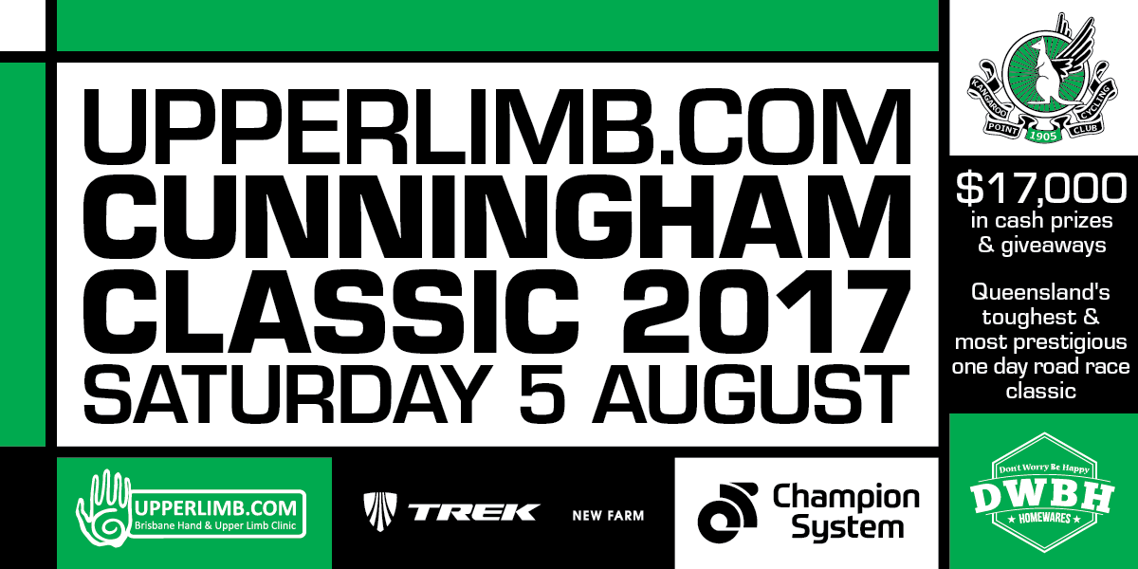

Article: For inclusion in newsletter

Queensland’s toughest Road Race… Are you up for the Challenge?
Registrations for Queensland’s toughest and most prestigious one day road race are now open. The Cunningham Classic is now in it’s 35th year and promises to be a huge success and a fantastic race with $17, 000 in cash prizes and giveaways to be won, 11 entry divisions and 2 courses.

Prepare yourself for a challenging 96km or 171km course starting from the picturesque Lockyer Valley and finishing in the breathtaking Darling Downs on Saturday the 5th of August 2017.

Gather at the start village (Dennis Minson Drive, Gatton) from 7:30 AM to register, enjoy a hot drink from Cappuccino Xpress and listen to information from race officials on the race course. There is plenty of space to ‘chill out’ and enjoy the pre-race festivities.

For supporters, the Drinks Station at Pilton Hall is an excellent place to chat and catch up over some delicious home cooking, tea, coffee & drinks from the Pilton Soldiers Memorial Hall.

The finish village is on Victoria Street, Warwick where you can join the fun and excitement and cheer riders across the finish line. A barbeque will be available for lunch and presentations for race divisions and prize winners will take place at the village from 12:00 midday.

Enter now or find out more about the Cunningham Classic including race programme, course maps, entry details, divisions, fees, FAQs and more…
Visit the website: www.cunninghamclassic.com.au
Email the Race Director: bettybathesby@bigpond.com
Phone the Race Director: Betty Bathersby on (07) 3207 3385 or 0415 523 405

